**Week 1 – Networking Basics and Topologies**

**Objective**

Understand networking concepts, create network topology diagrams, and identify key networking devices.

**Network Topologies**

1. Star Topology

* All devices connect to a central hub/switch.
* Easy to set up, scalable, and faults are isolated.
* If the central hub fails, the entire network fails.
* Small office LANs.

2. Bus Topology

* Devices are connected in a single line (shared backbone).
* Simple, low cost.
* Collisions increase with more devices; difficult troubleshooting.
* Early LANs, small temporary networks.

3. Mesh Topology

* Every device connects to every other device.
* High reliability, no single point of failure.
* Expensive, complex wiring.
* Data centers, military communication.

4. Ring Topology

* Each device is connected to exactly two other devices, forming a circular path for data to travel.
* Simple to install, predictable data transmission, and better performance than bus topology under heavy load.
* Failure of a single device or link can disrupt the entire network; troubleshooting is
* Older LANs, campus networks, and some WAN implementations (e.g., SONET, FDDI).

**Networking Devices**

Router : Connects different networks and directs data packets

. 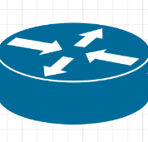

Switch: Connects devices in a LAN, forwards data intelligently using MAC addresses.

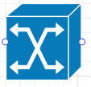

Firewall: Provides network security by filtering traffic (hardware/software).

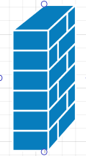

Hub : A basic device that broadcasts data to all connected devices.

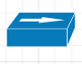

Access Point: Provides wireless connectivity to devices.

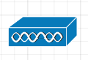

Modem : Converts digital signals to analog for ISP communication.

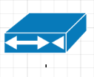

**Deliverable:**

[Blank diagram: Lucidchart](https://lucid.app/lucidchart/bcf1987d-e956-4ff0-9d2b-7a01a09dedba/edit?beaconFlowId=79ED2474BA40B733&invitationId=inv_cbd3bfad-9852-4dab-8ed1-88ae9786ea65&page=0_0)

Vedio link : <https://share.zight.com/wbugbyPA>